Instruction:

It is recommended to run this program in terminal, because some IDE have different settings which might not run it properly.

You can go through all the pieces by **left clicking** them using a mouse. (right-click on the right hand side fram)

You can rotate the piece shown by **right clicking** them. Once it rotate 4 times, you can click it one more time to flip it.

Place the first piece in the top left corner (Blokus’ rule) for Player blue by **clicking the top left square on the board**. (Yello: bottom left, Red bottom right, Green: top right)

Each new piece played must be placed so that it touches at least one piece of the same color, with only corner-to-corner contact allowed - edges cannot touch.

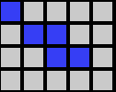

The scores are updated after each move, and it is shown in the right side.



You can click “skip turn” to skip. Once every player skips, the winner will be shown on the bottom right frame

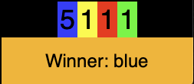

Once the GUI is closed, the output.txt will be generated with player’s info, including player’s score each round and who is(are) the winner(s).